20.38: a) Solving Eq. (20.14) for 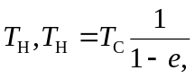 so the temperature change
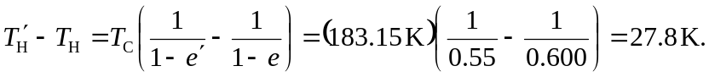

b) Similarly, 